Light

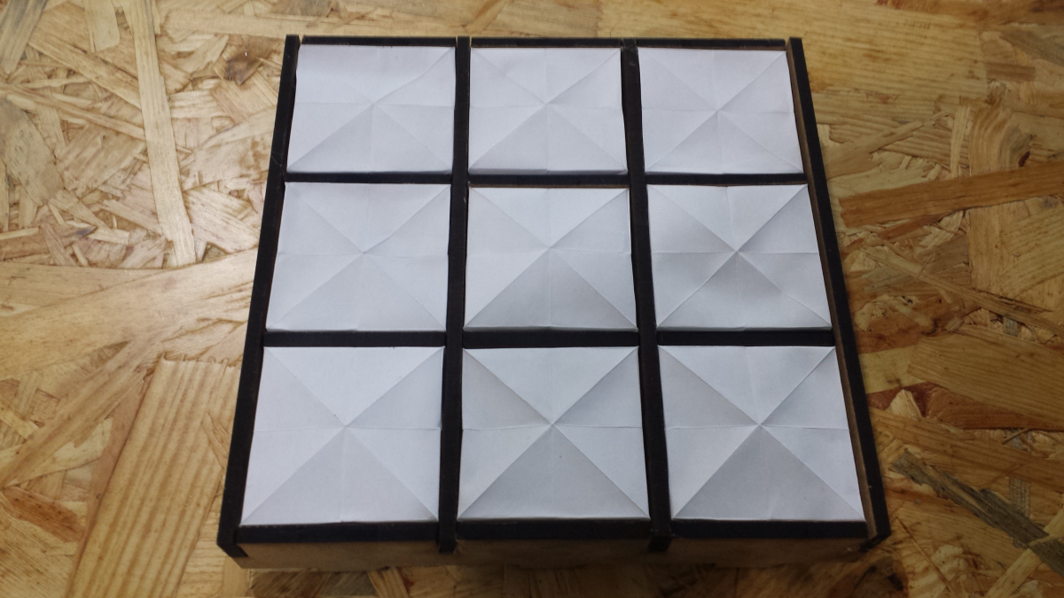

For the final project of the core course Light, I aimed to highlight the element of Asian heritage in technological design and to demonstrate the use of affordable materials in the creation of an aesthetic piece. The device consists of a custom designed and laser cut medium density fiberboard (MDF) circuit and a three by three origami paper diffuser. The use of origami diffuser emphasizes the crease and fold of the paper, bringing out the beauty of geometry and mathematics.

